**10 - Searching & Sorting**



**Department of Computer Science and Engineering | Rajalakshmi Engineering College**

**.**

**Ex. No.** **:** **10.1** **Date: 01.06.2024**

**Register No.: 231401100** **Name: Subbaiya M**



**Merge Sort**

**Write a Python program to sort a list of elements using the merge sort algorithm.**

**For example:**

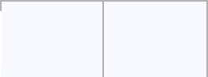

 **Input Result**



* **34568**

**65438**

**a=int(input())**

**l=[]**

**l.extend(input().split())**

**for i in range(a-1):**

**for j in range(a-1):**

**if(int(l[j])>int(l[j+1])):**

**t=int(l[j])**

**l[j]=int(l[j+1])**

**l[j+1]=t**

**for i in range(a):**

**print(int(l[i]),end=" ")**



**Department of Computer Science and Engineering | Rajalakshmi Engineering College**

**.**

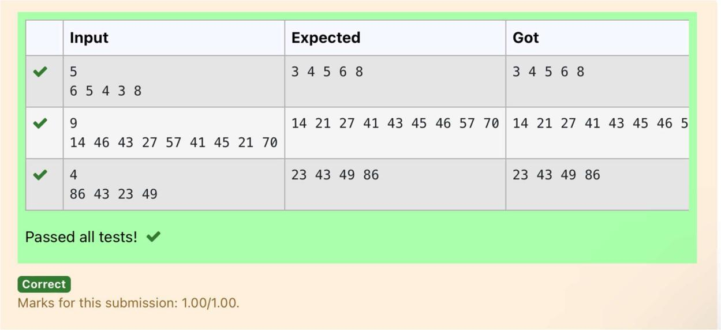

**Department of Computer Science and Engineering | Rajalakshmi Engineering College**

**.**



**Ex. No.** **:** **10.2** **Date: 01.06.2024**

**Register No.: 231401100** **Name: Subbaiya M**



**Bubble Sort**

**Given an listof integers, sort the array in ascending order using the Bubble Sort algorithm above. Once sorted, print the following three lines:**

1. **List is sorted in numSwaps swaps., where numSwaps is the number of swaps that took place.**
2. **First Element: firstElement, the first element in the sorted list.**
3. **Last Element: lastElement, the last element in the sorted list.**

**For example, given a worst-case but small array to sort: a=[6,4,1]. It took 3 swaps to sort the array. Output would be**

**Array is sorted in 3 swaps.**

**First Element: 1**

**Last Element: 6**

**Input Format**

**The** **first** **line** **contains** **an** **integer,n ,** **the** **size** **of** **the list a .**

**The second line contains n, space-separated integers a[i].**

**Constraints**

* **2<=n<=600**
* **1<=a[i]<=2x106.**

**Output Format**

**You must print the following three lines of output:**

1. **List is sorted in numSwaps swaps., where numSwaps is the number of swaps that took place.**
2. **First Element: firstElement, the first element in the sorted list.**
3. **Last Element: lastElement, the last element in the sorted list.**

**Sample Input 0**

**3**

**1 2 3**

**Sample Output 0**

**List is sorted in 0 swaps.**



**Department of Computer Science and Engineering | Rajalakshmi Engineering College**

**.**

**First Element: 1**

**Last Element: 3**

**For example:**

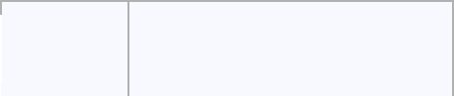

 **Input Result**

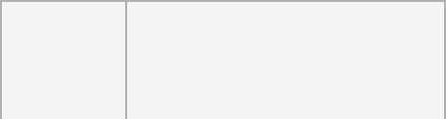

* **List is sorted in 3 swaps.**
* **2 1First Element: 1**

**Last Element: 3**

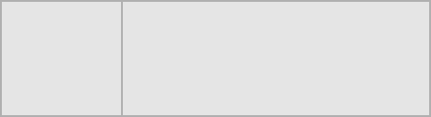

* **List is sorted in 4 swaps.**

**1 9 2 8 4 First Element: 1 Last Element: 9**

**def bubble_sort(arr):**

**n = len(arr)**

**swaps = 0**

**for i in range(n):**

**for j in range(0, n-i-1):**

**if arr[j] > arr[j + 1]:**

**# Swap elements**

**arr[j], arr[j + 1] = arr[j + 1], arr[j]**

**swaps += 1**

**return swaps**

* **Input the size of the list n = int(input())**
* **Input the list of integers**

**arr = list(map(int, input().split()))**

* **Perform bubble sort and count the number of swaps num_swaps = bubble_sort(arr)**



|  |  |
| --- | --- |
| **Department of Computer Science and Engineering | Rajalakshmi Engineering College** | **.** |
|  |  |



**# Print the number of swaps**

**print("List is sorted in", num_swaps, "swaps.")**

* **Print the first element print("First Element:", arr[0])**
* **Print the last element print("Last Element:", arr[-1])**

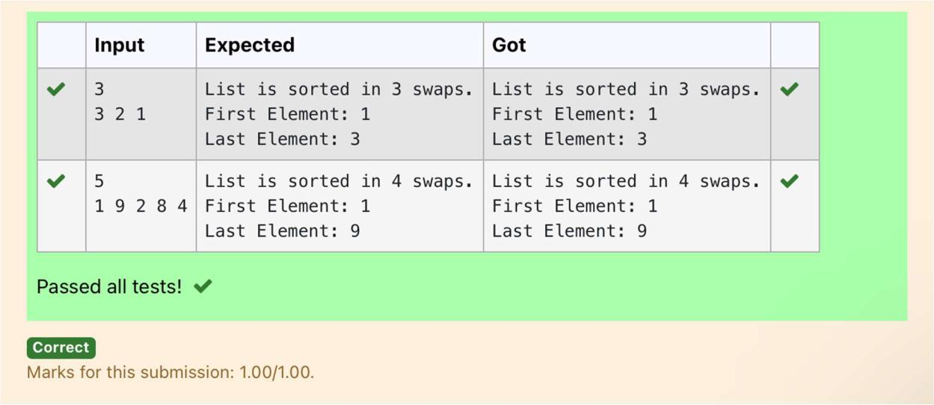

**Department of Computer Science and Engineering | Rajalakshmi Engineering College**

**.**

**Ex. No.** **:** **10.3** **Date: 01.06.2024**

**Register No.: 231401100** **Name: Subbaiya M**



**Peak Element**

**Given an list, find peak element in it. A peak element is an element that is greater than its neighbors.**

**An element a[i] is a peak element if**

**A[i-1] <= A[i] >=a[i+1] for middle elements. [0<i<n-1]**

**A[i-1] <= A[i] for last element [i=n-1]**

**A[i]>=A[i+1] for first element [i=0]**

**Input Format**

**The first line contains a single integer n , the length of A .**

**The second line contains n space-separated integers,A[i].**

**Output Format**

**Print peak numbers separated by space.**

**Sample Input**

**5**

**891026**

**Sample Output**

**10 6**

**For example:**

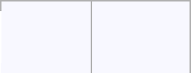

 **Input Result**

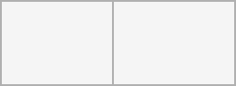

* **12 8**

**12368**

**def find_peak(arr):**

**peak_elements = []**



**Department of Computer Science and Engineering | Rajalakshmi Engineering College**

**.**

* **Check for the first element if arr[0] >= arr[1]:**

**peak_elements.append(arr[0])**

* **Check for middle elements**

**for i in range(1, len(arr) - 1):**

**if arr[i - 1] <= arr[i] >= arr[i + 1]:**

**peak_elements.append(arr[i])**

* **Check for the last element if arr[-1] >= arr[-2]:**

**peak_elements.append(arr[-1])**

**return peak_elements**

* **Input the length of the list n = int(input())**
* **Input the list of integers**

**arr = list(map(int, input().split()))**

* **Find peak elements and print the result peak_elements = find_peak(arr) print(*peak_elements)**



**Department of Computer Science and Engineering | Rajalakshmi Engineering College**

**.**

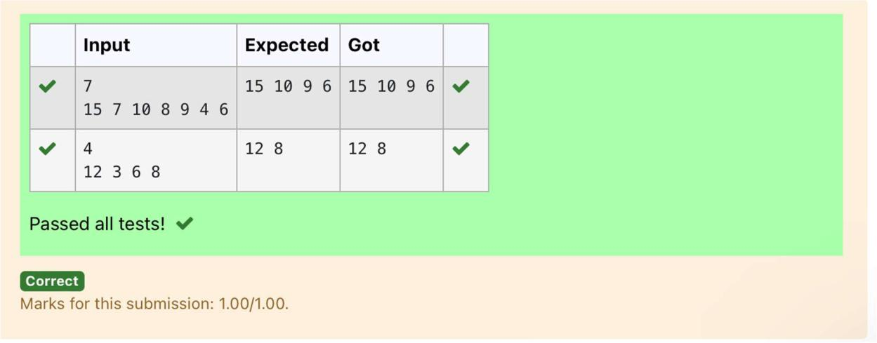

**Department of Computer Science and Engineering | Rajalakshmi Engineering College**

**.**



**Ex. No.** **:** **10.4** **Date: 01.06.2024**

**Register No.: 231401100** **Name: Subbaiya M**



**Binary Search**

**Write a Python program for binary search.**

**For example:**

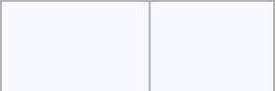

|  |  |
| --- | --- |
| **Input** | **Result** |
| **12358** | **False** |
| **6** |  |
| **3594542** | **True** |
| **42** |  |

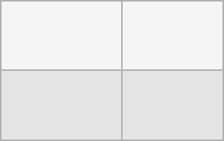

**a = input().split(",")**

**b = input()**

**print(b in a)**

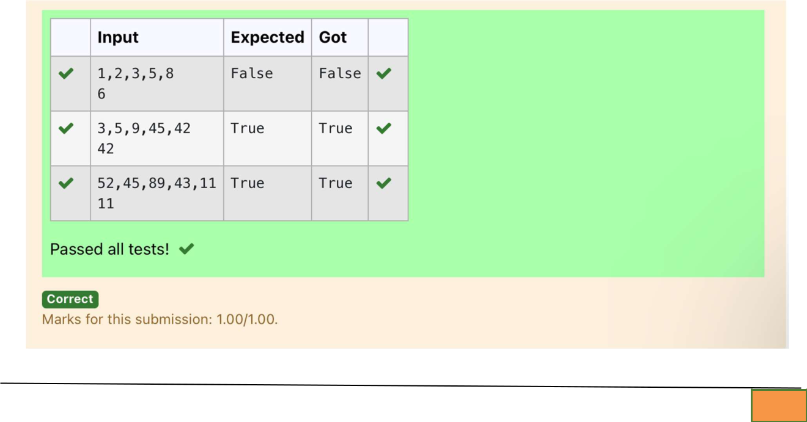

**Department of Computer Science and Engineering | Rajalakshmi Engineering College**

**.**

**Ex. No.**

**:**

**10.5**

**Date: 01.06.2024**

**Register No.: 231401100**

**Name: Subbaiya M**



**Frequency of Elements**

**To find the frequency of numbers in a list and display in sorted order.**

**Constraints:**

**1<=n, arr[i]<=100**

**Input:**

**1687949068145**

**output:**

* **2**

**4 2**

**5 1**

**68 2**

**79 1**

**90 1**

**For example:**

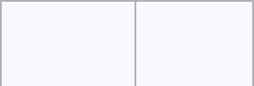

|  |  |
| --- | --- |
| **Input** | **Result** |
| **435345** | **3 2** |
|  | **4 2** |
|  | **5 2** |

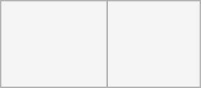

**def count_frequency(arr):**

**frequency = {}**



|  |  |
| --- | --- |
| **Department of Computer Science and Engineering | Rajalakshmi Engineering College** | **.** |
|  |  |



* **Count the frequency of each number in the list for num in arr:**

**frequency[num] = frequency.get(num, 0) + 1**

* **Sort the dictionary based on keys**

**sorted_frequency = sorted(frequency.items())**

* + **Print the frequency of each number for num, freq in sorted_frequency:**

**print(num, freq)**

* **Input the list of numbers**

**arr = list(map(int, input().split()))**

* **Count the frequency and print the result count_frequency(arr)**



**Department of Computer Science and Engineering | Rajalakshmi Engineering College**

**.**

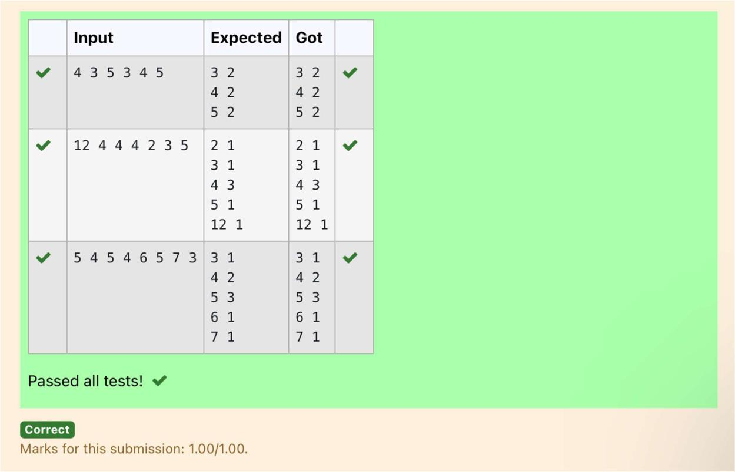

**Department of Computer Science and Engineering | Rajalakshmi Engineering College**

**.**

